EXPERIMENT – 1

STUDENT FORM :
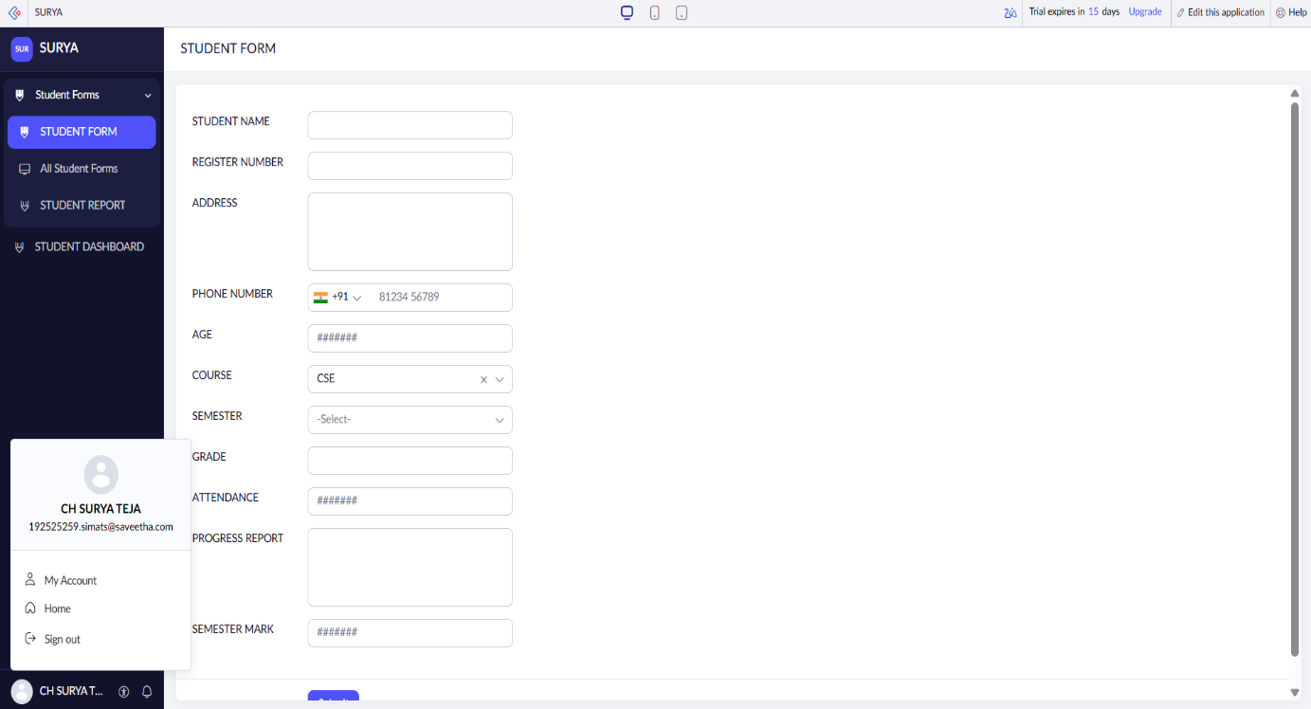
STUDENT REPORT :
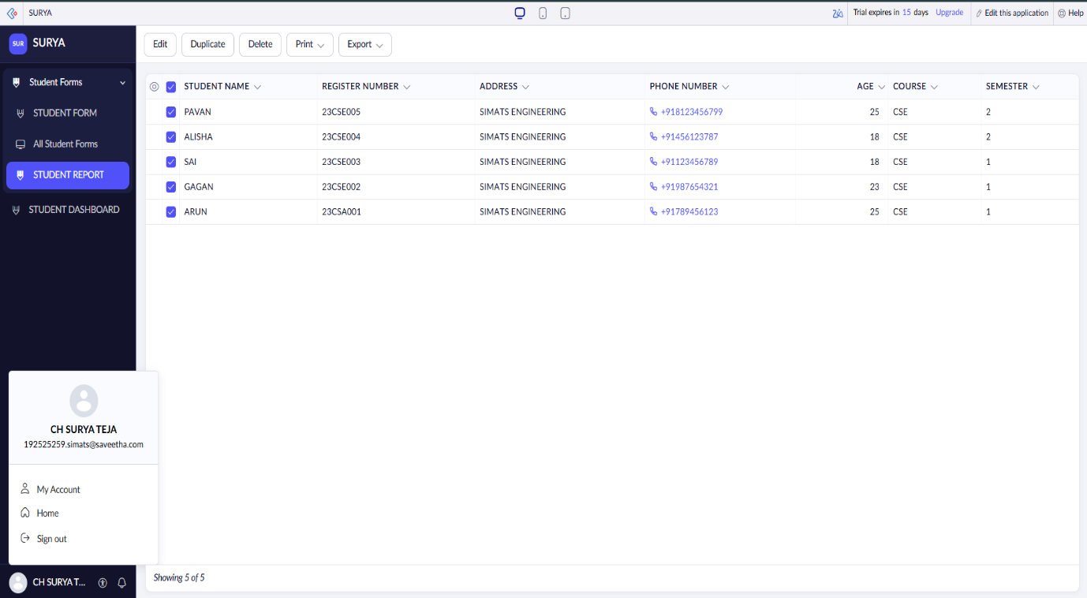

STUDENT DASHBOARD :
